NT21 Assignment 2

Linux, Numeric Systems, Static IP address/subnets configuration, ARP

Task 1: Do Linux Tutorial

Go to <http://www.ee.surrey.ac.uk/Teaching/Unix/unix2.html> and do the 2nd basic Unix tutorial.

Provide screenshots of all exercises 2a and 2b. Do all subsections of this tutorial – all of them are really useful!

Task 2: Conversion Between Different Numeric Systems

Do not use Internet tools for the following conversions. We will question you how to do this without any tools.

Convert the following numbers from decimal to binary and show how you calculated it:

114 – 1110010

64-32-16-2

129 – 10000001

128-1

191 – 10111111

64-16-8-4-2-1

102 - 1100110

64-32-4-2

248 – 11111000

128-64-32-16-8

221 – 11011101

128-64-16-8-4-1

Convert the following numbers from decimal to hexadecimal and show how you calculated it:

Ans eerste getal ans van de eerste ans 2 is de tweede. Omgezet naar hexa via powerpoint tabel

14 – E

129 – 81

129 / 16 = 129 – ans \* 16 = ans 2

191 - BF

191 / 16 = 191 – ans \* 16

102 - 66

102 / 16 = 102 – ans \* 16

248 - F8

248 / 16 = 248 – ans \* 16

221 - DD

221 / 16 = 221 – ans \* 16

Convert the following numbers from hexadecimal to binary and show how you calculated it:

Ik heb de F en de F opgesplit zo dat het makkelijker te maken omzetten

FF = 15 \* 16 + 15 = 255, F F = 1111 1111

F8 = 15 \* 16 + 8 = 248, F 8 = 1111 1000

ED = 14 \* 16 + 13 = 237, E D = 1110 1101

A5 = 10 \* 16 + 5 = 165, A 5 = 1010 0101

5A = 5 \* 16 + 10 = 90, 5 A = 0101 1010

55 = 5 \* 16 + 5 = 85, 5 5 = 0101 0101

AA = 10 \* 16 + 10 = 170, A A = 1010 1010

12 = 1 \* 16 + 2 = 18, 1 2 = 0001 0010

36 = 3 \* 16 + 6 = 54, 3 6 = 0011 0110

48 = 4 \* 16 + 8 = 72, 4 8 = 0100 1000

Task 3: IP Address Conversions

Convert the following IP addresses to base 2 notations:

192.168.0.1 =

10000001 = C0

10101000 = A8

0 = 0

1 = 1

223.255.255.255 =

11011111 = DF

11100001 = E1

11100001 = E1

11100001 = E1

172.16.0.1 =

10101100 = AC

10000 = 10

0 = 0

1 = 1

0.0.0.7 =

0 = 0

0 = 0

0 = 0

111 = 7

10.3.251.129 =

1010 = A

11 = 3

11111011= FB

10000001 = 81

What would the above IP addresses look like when you represent the value of each byte into base 16 (hexadecimal) notations?

Task 4: IP addresses, subnets, masks, broadcast addresses

Calculate for each of the following IP addresses its subnet mask in dotted notation, its network address, the number of the nodes supported by this network and the host id of this IP address:

192.168.0.1/24

SubnetMask: 11111111.11111111.11111111.00000000

NetworkAddres: 192.168.0.0

Number Nodes: 2^8-2 = 254

HostID: 1

122.233.128.5/16

SubnetMask: 11111111.11111111.00000000.00000000

NetworkAddres: 122.233.0.0

Number Nodes: 2^16-2 = 65534

HostID: 128.5

10.0.0.1/8

SubnetMask: 11111111.00000000.00000000.00000000

NetworkAddres: 10.0.0.0

Number Nodes: 2^24-2 = 16777214

HostID: 0.0.1

145.24.164.2/20

SubnetMask: 11111111.11111111.11110000.00000000

NetworkAddres: 145.24.160.0

Number Nodes: 2^12-2 = 4094

HostID: 4.2

Task 5: Build A Simple Netkit Network

Read the explanation of the basic Netkit commands and use them to build a simple network of two nodes connected to a LAN network.

*Note : LAN network is being called collision domain in Netkit*

Try the following configurations:

A)

Configure IP addresses of the 2 nodes by using the “ifconfig” command explained in the theory lesson.

ifconfig eth0 102.10.2.2 netmask 255.0.0.0

1. Node1 has an IP address 102.10.2.1/24
2. Node2 has an IP address 102.20.2.1/24

Check whether your 2 nodes can reach each other by using ICMP ping command between these two nodes.

1. What is the result of the ping? Can you explain it? Provide a screenshot.

De ping werkt niet omdat de ips niet in de zelfde netmask zitten



2. Look at the ARP entries of your Node1 and Node2.

Which command do you use? Which ARP entries are there?

 

B) Configure IP addresses of the 2 nodes in such a way that their subnet mask is 255.255.255.0 and the ping between them is successful.

1. Provide a screenshot of your configuration and successful ping.

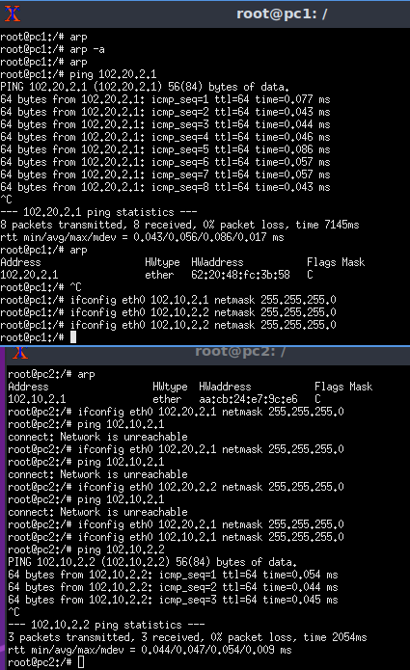

2. After successful ping ARP entries of both nodes should be changed. Provide a screenshot of the new ARP situation and explain it. What is the command to clear the ARP cache?

Omdat het ipaddres veranderd is zijn de arps ook veranderd.

arp –d 102.10.2.1

arp –d 102.10.2.2

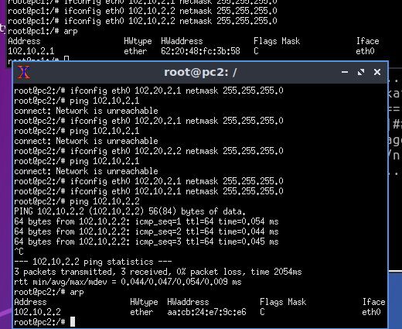

Task 6: Fill In Canvas Quiz Week 2

Task 7 (Optional): Subnetting Game

Go to the following page : <https://www.subnetting.net/Start.aspx>

and do the subnetting game. You should achieve at least 5 correct answers within the given time (5 minutes). You are allowed to skip some questions. It doesn’t matter how many wrong answers you have if you can achieve at least 5 correct answers. Of course, higher scores and less incorrect answers are appreciated.

Tip : use paper and some table like this:

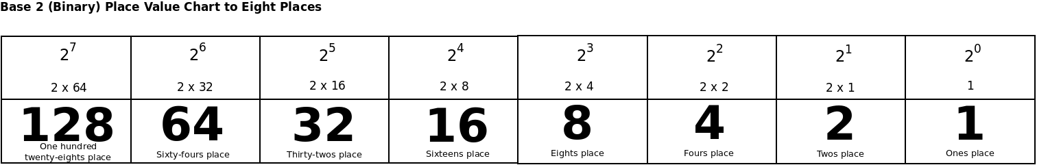

As a proof of achieving above described goal provide a screenshot from the result page of the game from which is to be seen that you achieved at least 5 correct answers.